Using data from 330 different ski resorts across the country within the same market share as Big Mountain Resort, we analyzed how different features of a resort impact the ticket price a resort is able to support. Among all the different features we had on each resort, only 8 ended up being useful in our pricing model, with the bulk of the predictive power coming from the top 4 features, the number of fast quad lifts, the total number of ski runs, the area covered by snow 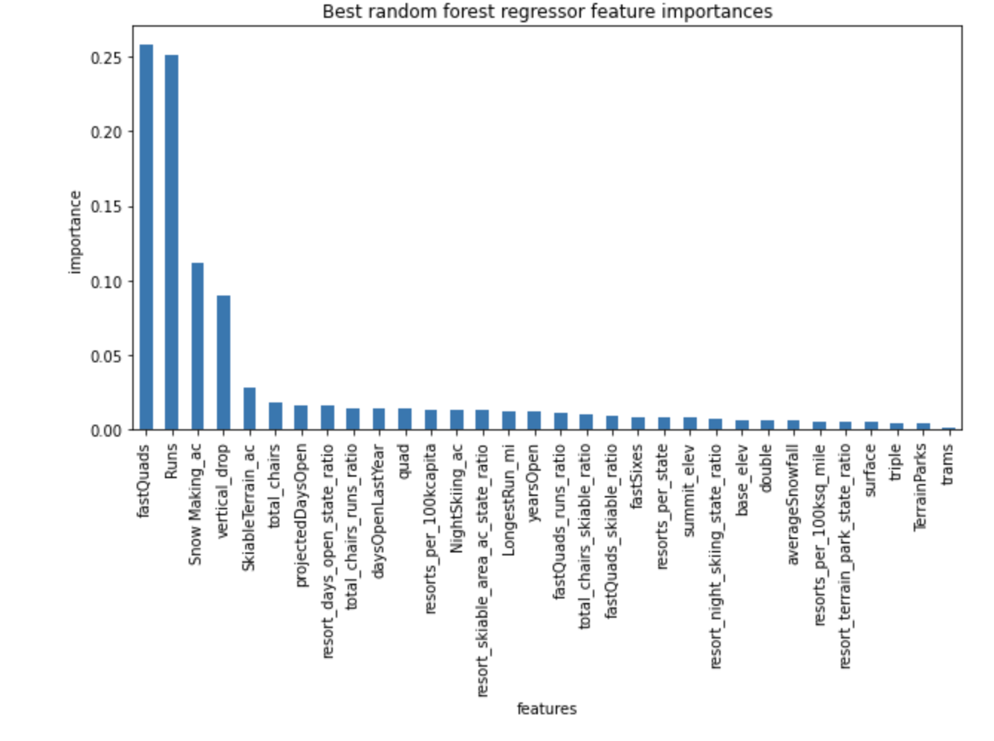making machines, and the largest vertical drop offered in the park. The importance of these features are visualized in the chart below.

The amenities or features at Big Mountain Resort rank in the upper quartile among all resorts, especially in the features which were determined to be the most influential on price. Due to this, our model predicts that, with no further changes to the park’s current features, Big Mountain Resort could support an increase in ticket price of over 15%, increasing from the current price of $80 to $94.22. Additionally, our model predicts that a construction project in which a new run & chair lift is added, in addition to increasing the vertical drop by 150 feet, would increase the supportable ticket price an additional $1.99. However, adding distance to the longer ski runs, and adding snow machine coverage do not seem to be viable routes for increasing the supportable ticket price. Finally, when looking at the impact of closing 1 or more runs, our model predicts that removing 1 run alone will not decrease the supportable ticket price. Closing 2 and 3 runs results in a predicted ticket price decrease of approximately $0.40 and $.70 respectively, with no further decrease predicted between removing 4 to 6 runs.

